

**UNIVERSITY INSTITUTE OF ENGINEERING**

**Department of Computer Science & Engineering**

**Subject Name:** Competitive Coding

**Subject Code:** 20CSP-314

**Submitted to: Submitted by:**

Er. Mamta Punia Name: Sahil Kaundal

UID: 21BCS8197

Section: 616

Group: A

**INDEX**

|  |  |  |  |  |  |  |
| --- | --- | --- | --- | --- | --- | --- |
| **Ex. No** | **List of Experiments** | **Conduct (MM: 12)** | **Viva**  **(MM: 10)** | **Record (MM: 8)** | **Total**  **(MM: 30)** | **Remarks/Signature** |
| 1 | To demonstrate the concept of Array. |  |  |  |  |  |
|  |  |  |  |  |  |  |
|  |  |  |  |  |  |  |
|  |  |  |  |  |  |  |
|  |  |  |  |  |  |  |
|  |  |  |  |  |  |  |
|  |  |  |  |  |  |  |
|  |  |  |  |  |  |  |
|  |  |  |  |  |  |  |

**Experiment 1.1**

**Student Name:** Sahil Kaundal **UID:** 21BCS8197

**Branch:** BE CSE (Lateral Entry) **Section/Group:** 616/A

**Semester:** 5th **Date of Performance:** 26/08/2022

**Subject Name:** CC Lab **Subject Code:** 20CSP-314

1. **Aim/Overview of the practical:**

Given an array of integers, print 's elements in reverse order as a single line of space separated numbers.

Example: Arr = {1 2 3 4}

Print 4 3 2 1. Each integer is separated by one space.

1. **Task to be done:** Using for loop approach to start from initial index to last and then print the element from the last to print the reverse of an array.
2. **Apparatus / Simulator Used:**

* Windows 7 or above
* Google Chrome

**4. Algorithm:**

**Complexity for this approach is O(n) as we are using for loop.**

Step 1: Start.

Step 2: Take input size of an array.

Step 3: Start the for loop and insert all the elements of an array.

Step 4: Now start the for loop from the end of an array and print the array in reverse order.

Step 5: End.

**5. Code:**

import java.io.*;

import java.util.*;

public class Solution {

    public static void main(String[] args) {

        Scanner in = new Scanner(System.in);

        int n = in.nextInt();

        int[] arr = new int[n];

        for(int i=0; i < n; i++){

            arr[i] = in.nextInt();

        }

        in.close();

        for(int i = n - 1; i > -1; i--){

            System.out.print(arr[i] + " ");

        }

    }

}

1. **Result/Output/Writing Summary:**

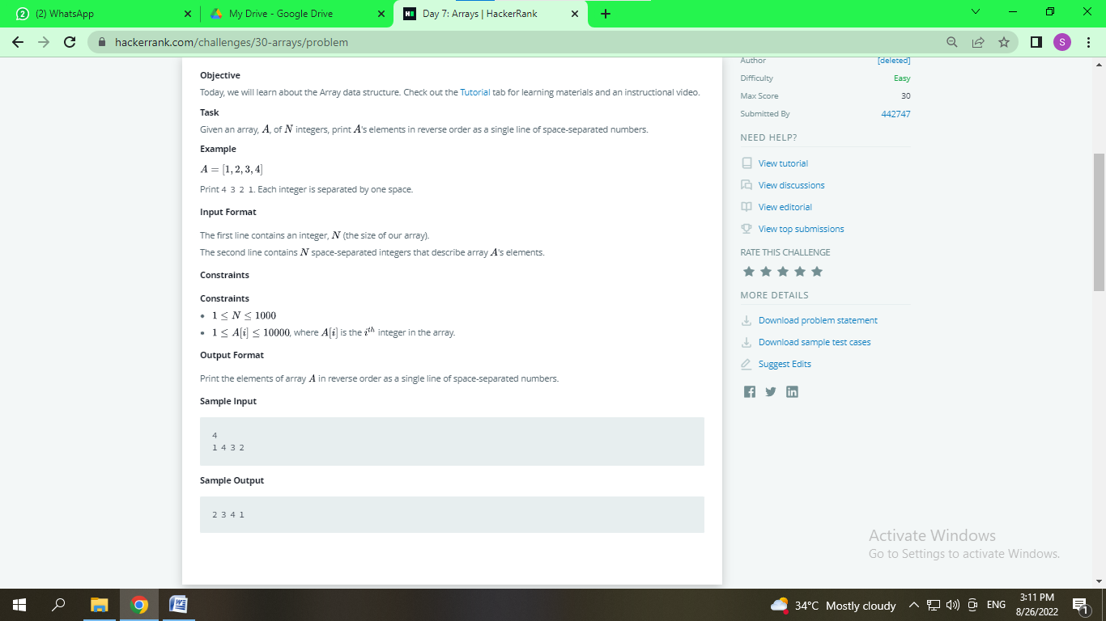

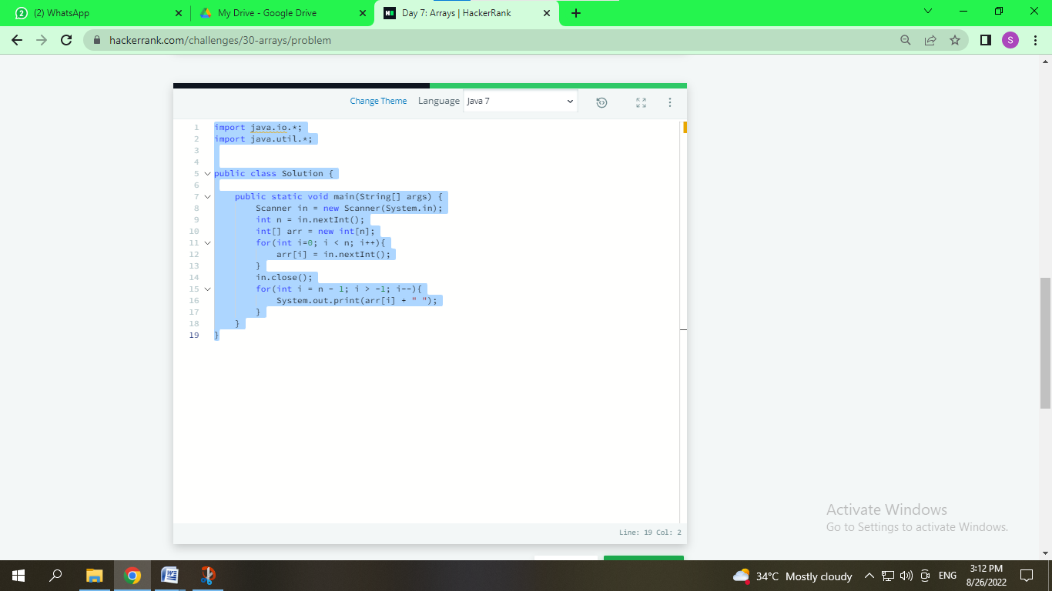

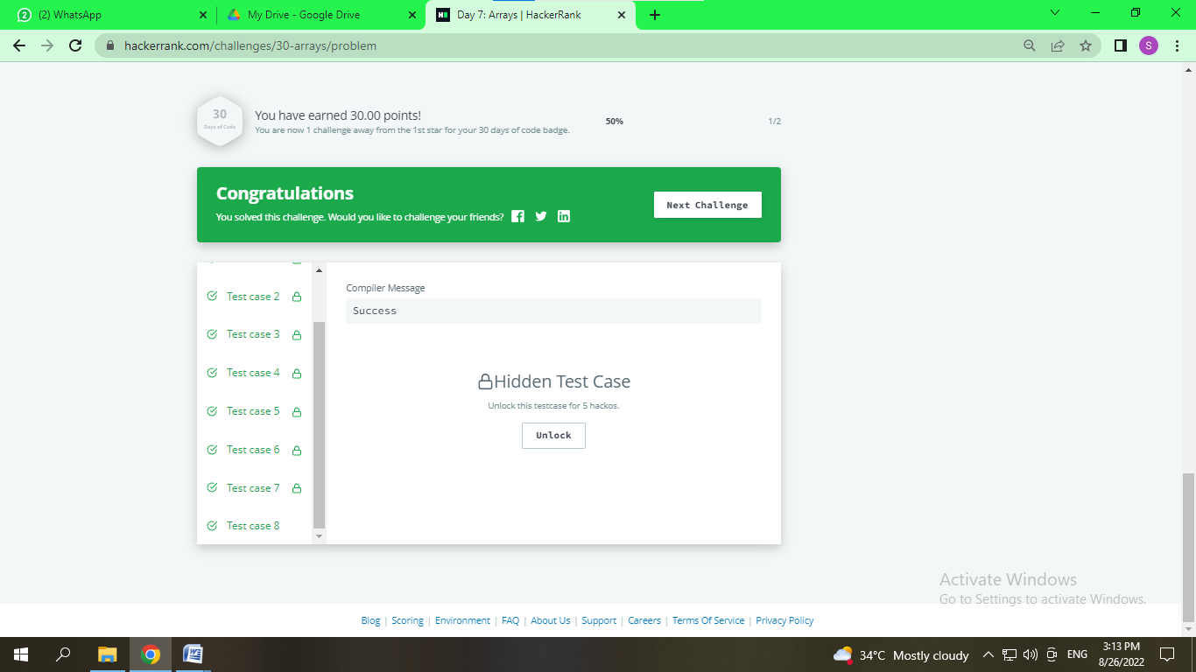

**Learning outcomes (What I have learnt):**

1. We understand the concept of how to implement and use the array data structure.
2. We understand how to reverse array.

**Experiment 1.2**

1. **Aim/Overview of the practical:**

Given an array of integers, find the sum of its elements.

Example: If the array is {1,2,3} then it returns output as 6.

**Function Description**

Complete the simple array sum function in the editor below. It must return the sum of the array elements as an integer.

1. **Task to be done:** Using for loop approach to start from initial index to last and then add all the elements of an array to a sum variable and then return it as an output.
2. **Apparatus / Simulator Used:**

* Windows 7 or above
* Google Chrome

1. **Algorithm:**

**Complexity for this approach is O(n) as we are using for loop.**

Step 1: Start.

Step 2: Take input size of an array and made a variable sum which store the value of final sum.

Step 3: Start the for loop and insert all the elements of an array.

Step 4: Add each element of an array to the sum variable and return the final sum as output and print it.

Step 5: End.

1. **Code:**

import java.io.*;

import java.util.*;

public class Solution {

    public static void main(String[] args) throws Exception

    {

        BufferedReader br = new BufferedReader(new InputStreamReader(System.in));

        br.readLine();

        int output=0;

        String[] input = br.readLine().split(" ");

        for(String value:input)

        {

            output += Integer.parseInt(value);

        }

        System.out.println(output);

    }

}

1. **Result/Output/Writing Summary:**

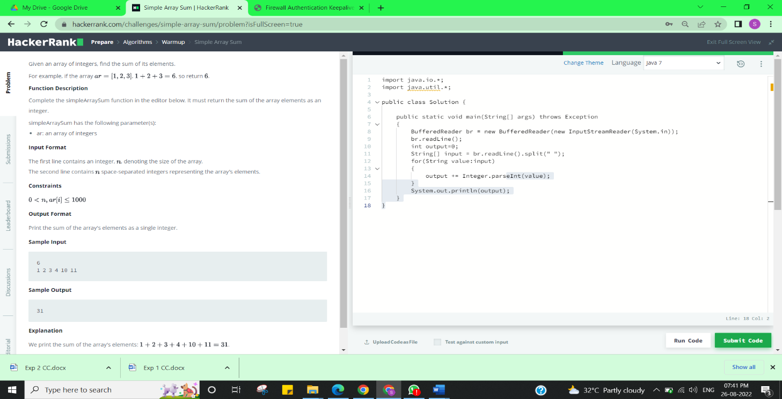

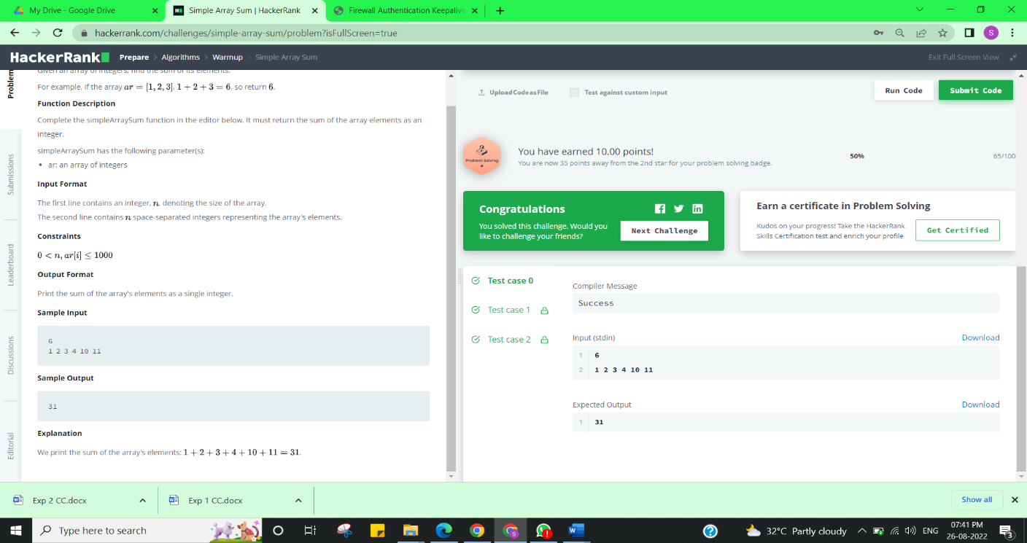

**Learning outcomes (What I have learnt):**

1. We understand the concept of how to implement and use the array data structure.
2. We understand how to evaluate the sum of array.

**Evaluation Grid (To be created as per the SOP and Assessment guidelines by the faculty):**

|  |  |  |  |
| --- | --- | --- | --- |
| Sr. No. | Parameters | Marks Obtained | Maximum Marks |
| 1. |  |  |  |
| 2. |  |  |  |
| 3. |  |  |  |
|  |  |  |  |